Southwestern Oklahoma State University

Oklahoma
Economy Overview

Region: NEOK

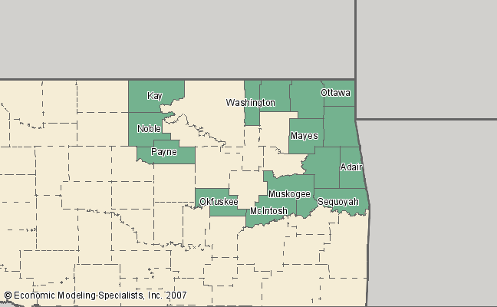

Report Produced by Economic Modeling Specialists Inc. www.economicmodeling.com


Industry Overview

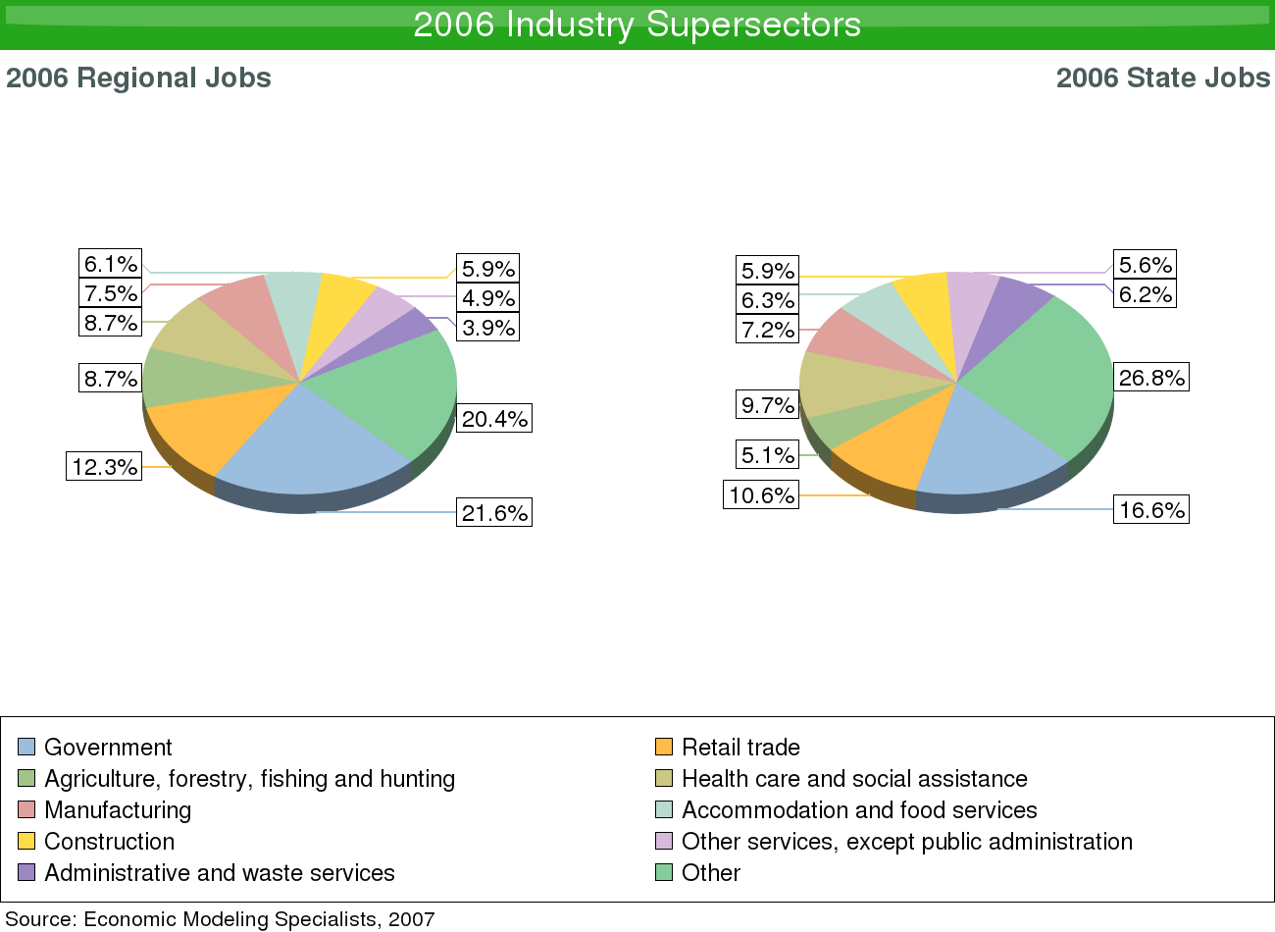

Description | 2006 Regional Jobs | % Regional Jobs | 2006 State Jobs | % State Jobs
Agriculture, forestry, fishing and hunting | 22,464 | 8.718% | 105,290 | 5.107%
Mining | 8,229 | 3.194% | 61,693 | 2.992%
Utilities | 1,283 | 0.498% | 9,822 | 0.476%
Construction | 15,215 | 5.905% | 120,727 | 5.856%
Manufacturing | 19,379 | 7.521% | 148,913 | 7.223%
Wholesale trade | 4,904 | 1.903% | 61,983 | 3.006%
Retail trade | 31,610 | 12.267% | 218,161 | 10.582%
Transportation and warehousing | 6,500 | 2.523% | 68,443 | 3.32%
Information | 2,218 | 0.861% | 34,394 | 1.668%
Finance and insurance | 6,859 | 2.662% | 76,256 | 3.699%
Real estate and rental and leasing | 6,003 | 2.33% | 66,430 | 3.222%
Professional and technical services | 9,458 | 3.67% | 107,367 | 5.208%
Management of companies and enterprises | 919 | 0.357% | 12,507 | 0.607%
Administrative and waste services | 10,082 | 3.913% | 127,780 | 6.198%
Educational services | 1,664 | 0.646% | 25,596 | 1.242%
Health care and social assistance | 22,372 | 8.682% | 200,769 | 9.738%
Arts, entertainment, and recreation | 4,601 | 1.786% | 27,476 | 1.333%
Accommodation and food services | 15,768 | 6.119% | 129,950 | 6.303%
Other services, except public administration | 12,580 | 4.882% | 115,515 | 5.603%
Government | 55,570 | 21.566% | 342,610 | 16.618%
Source: Economic Modeling Specialists, Inc. - 5/07
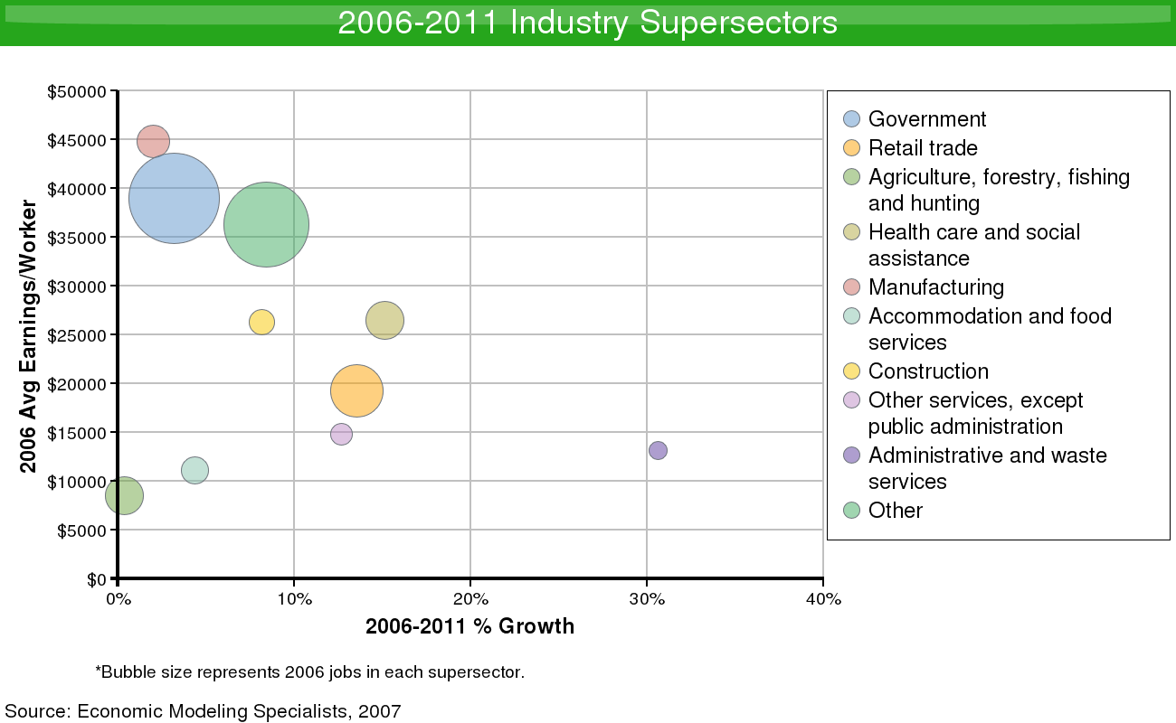

Description | 2006 Jobs | 2011 Jobs | Growth | % Growth | 2006 EPW
Agriculture, forestry, fishing and hunting | 22,464 | 22,544 | 80 | 0% | $8,593
Mining | 8,229 | 9,313 | 1,084 | 13% | $67,207
Utilities | 1,283 | 1,346 | 62 | 5% | $80,676
Construction | 15,215 | 16,459 | 1,244 | 8% | $28,428
Manufacturing | 19,379 | 19,769 | 390 | 2% | $45,690
Wholesale trade | 4,904 | 5,277 | 373 | 8% | $41,705
Retail trade | 31,610 | 35,890 | 4,281 | 14% | $21,829
Transportation and warehousing | 6,500 | 6,669 | 169 | 3% | $40,130
Information | 2,218 | 2,261 | 43 | 2% | $39,872
Finance and insurance | 6,859 | 7,808 | 949 | 14% | $36,888
Real estate and rental and leasing | 6,003 | 7,406 | 1,403 | 23% | $17,958
Professional and technical services | 9,458 | 8,535 | -923 | -10% | $36,179
Management of companies and enterprises | 919 | 970 | 51 | 6% | $27,230
Administrative and waste services | 10,082 | 13,170 | 3,088 | 31% | $17,181
Educational services | 1,664 | 1,795 | 131 | 8% | $17,850
Health care and social assistance | 22,372 | 25,756 | 3,384 | 15% | $30,536
Arts, entertainment, and recreation | 4,601 | 5,698 | 1,096 | 24% | $22,170
Accommodation and food services | 15,768 | 16,453 | 685 | 4% | $11,598
Other services, except public administration | 12,580 | 14,175 | 1,595 | 13% | $16,642
Government | 55,570 | 57,326 | 1,756 | 3% | $40,198
Source: Economic Modeling Specialists, Inc. - 5/07
Occupation Overview

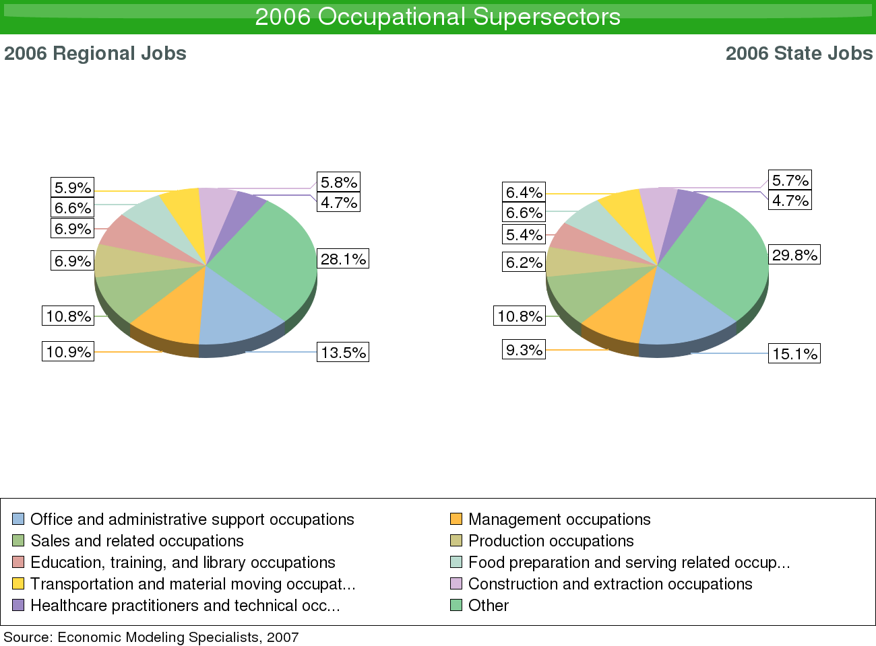

SOC Code | Description | 2006 Regional Jobs | % Regional Jobs | 2006 State Jobs | % State Jobs
11-0000 | Management occupations | 28,101 | 10.906% | 191,943 | 9.312%
13-0000 | Business and financial operations occupations | 8,304 | 3.223% | 79,718 | 3.867%
15-0000 | Computer and mathematical science occupations | 2,885 | 1.12% | 29,960 | 1.453%
17-0000 | Architecture and engineering occupations | 2,729 | 1.059% | 29,362 | 1.424%
19-0000 | Life, physical, and social science occupations | 2,426 | 0.941% | 18,952 | 0.919%
21-0000 | Community and social services occupations | 4,305 | 1.671% | 26,091 | 1.266%
23-0000 | Legal occupations | 1,393 | 0.541% | 16,930 | 0.821%
25-0000 | Education, training, and library occupations | 17,663 | 6.855% | 111,034 | 5.386%
27-0000 | Arts, design, entertainment, sports, and media occupations | 3,936 | 1.527% | 34,849 | 1.691%
29-0000 | Healthcare practitioners and technical occupations | 12,059 | 4.68% | 96,991 | 4.705%
31-0000 | Healthcare support occupations | 6,835 | 2.653% | 51,325 | 2.49%
33-0000 | Protective service occupations | 4,508 | 1.749% | 35,095 | 1.703%
35-0000 | Food preparation and serving related occupations | 17,066 | 6.623% | 136,315 | 6.613%
37-0000 | Building and grounds cleaning and maintenance occupations | 9,481 | 3.679% | 76,493 | 3.711%
39-0000 | Personal care and service occupations | 7,868 | 3.053% | 67,737 | 3.286%
41-0000 | Sales and related occupations | 27,708 | 10.753% | 222,897 | 10.813%
43-0000 | Office and administrative support occupations | 34,685 | 13.461% | 311,432 | 15.108%
45-0000 | Farming, fishing, and forestry occupations | 4,882 | 1.895% | 23,847 | 1.157%
47-0000 | Construction and extraction occupations | 14,910 | 5.786% | 117,350 | 5.693%
49-0000 | Installation, maintenance, and repair occupations | 10,696 | 4.151% | 87,454 | 4.243%
51-0000 | Production occupations | 17,765 | 6.894% | 126,808 | 6.152%
53-0000 | Transportation and material moving occupations | 15,193 | 5.896% | 132,323 | 6.419%
55-0000 | Military Occupations | 2,278 | 0.884% | 36,437 | 1.768%
Source: Economic Modeling Specialists, Inc. - 5/07
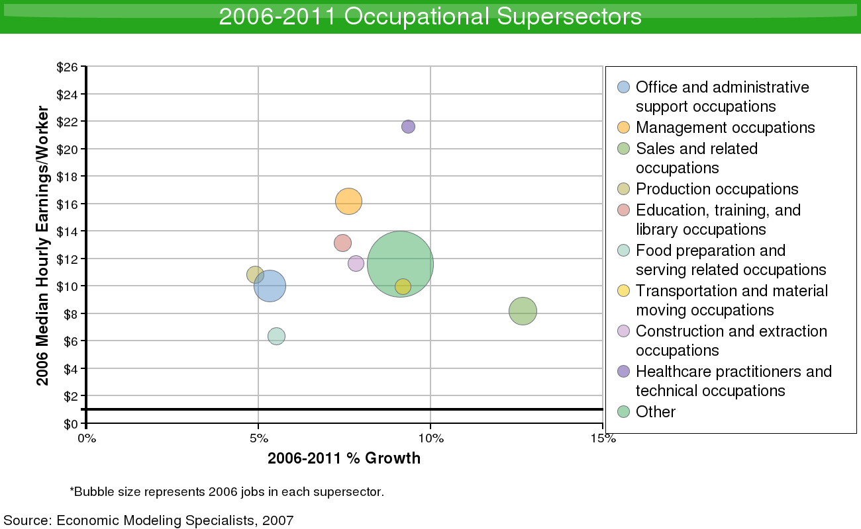

SOC Code | Description | 2006 Jobs | 2011 Jobs | Growth | % Growth | 2006 EPW
11-0000 | Management occupations | 28,101 | 30,243 | 2,141 | 8% | $17.40
13-0000 | Business and financial operations occupations | 8,304 | 9,183 | 879 | 11% | $17.56
15-0000 | Computer and mathematical science occupations | 2,885 | 3,014 | 129 | 4% | $19.50
17-0000 | Architecture and engineering occupations | 2,729 | 2,769 | 40 | 1% | $24.85
19-0000 | Life, physical, and social science occupations | 2,426 | 2,635 | 209 | 9% | $20.27
21-0000 | Community and social services occupations | 4,305 | 4,865 | 560 | 13% | $13.27
23-0000 | Legal occupations | 1,393 | 1,379 | -14 | -1% | $22.79
25-0000 | Education, training, and library occupations | 17,663 | 18,980 | 1,316 | 7% | $14.10
27-0000 | Arts, design, entertainment, sports, and media occupations | 3,936 | 4,158 | 222 | 6% | $12.03
29-0000 | Healthcare practitioners and technical occupations | 12,059 | 13,186 | 1,128 | 9% | $23.65
31-0000 | Healthcare support occupations | 6,835 | 7,920 | 1,086 | 16% | $8.72
33-0000 | Protective service occupations | 4,508 | 4,741 | 232 | 5% | $12.69
35-0000 | Food preparation and serving related occupations | 17,066 | 18,008 | 942 | 6% | $6.71
37-0000 | Building and grounds cleaning and maintenance occupations | 9,481 | 10,689 | 1,208 | 13% | $7.31
39-0000 | Personal care and service occupations | 7,868 | 9,217 | 1,348 | 17% | $6.87
41-0000 | Sales and related occupations | 27,708 | 31,219 | 3,510 | 13% | $9.20
43-0000 | Office and administrative support occupations | 34,685 | 36,534 | 1,849 | 5% | $10.55
45-0000 | Farming, fishing, and forestry occupations | 4,882 | 4,927 | 45 | 1% | $7.01
47-0000 | Construction and extraction occupations | 14,910 | 16,078 | 1,168 | 8% | $12.54
49-0000 | Installation, maintenance, and repair occupations | 10,696 | 11,522 | 826 | 8% | $14.17
51-0000 | Production occupations | 17,765 | 18,636 | 872 | 5% | $11.37
53-0000 | Transportation and material moving occupations | 15,193 | 16,590 | 1,398 | 9% | $10.86
55-0000 | Military Occupations | 2,278 | 2,125 | -153 | -7% | $16.58
Source: Economic Modeling Specialists, Inc. - 5/07

Demographic Overview

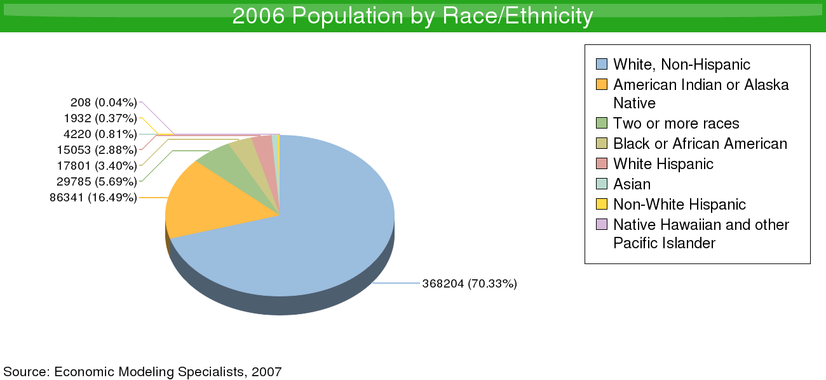

Ethnicity | 2006 Population | % of Region
White, Non-Hispanic | 368,204 | 70.33%
American Indian or Alaska Native | 86,341 | 16.49%
Two or more races | 29,785 | 5.69%
Black or African American | 17,801 | 3.4%
White Hispanic | 15,053 | 2.88%
Asian | 4,220 | 0.81%
Non-White Hispanic | 1,932 | 0.37%
Native Hawaiian and other Pacific Islander | 208 | 0.04%
Source: Economic Modeling Specialists, Inc. - 5/07
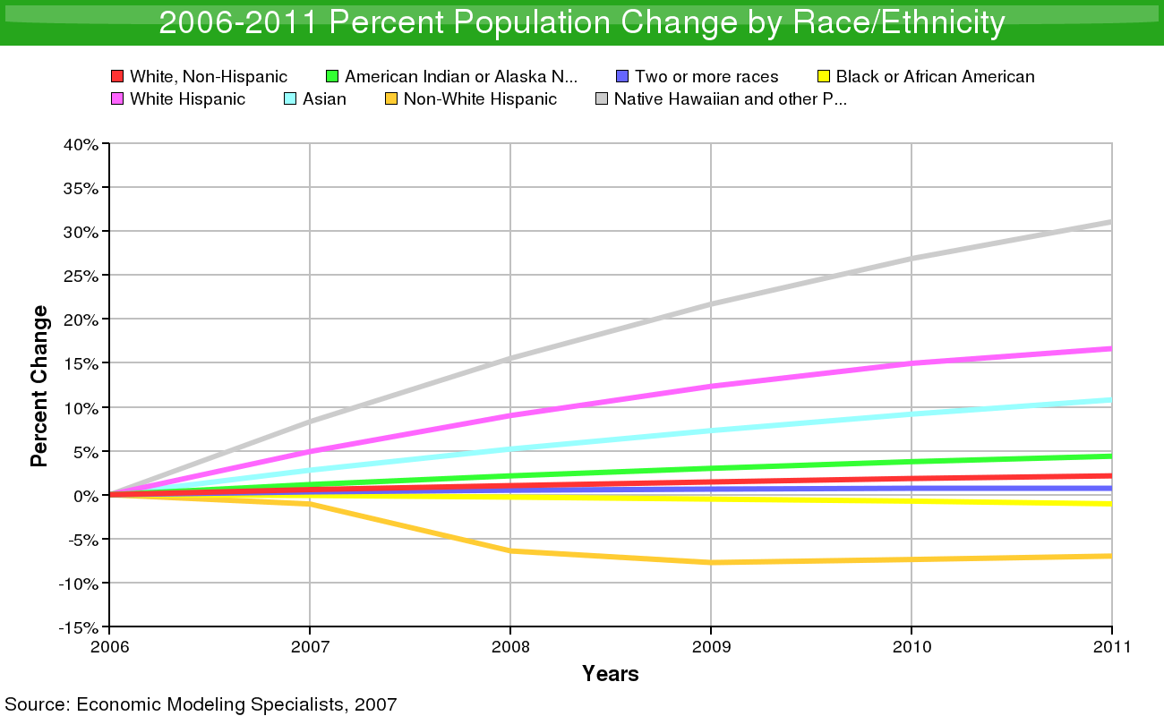

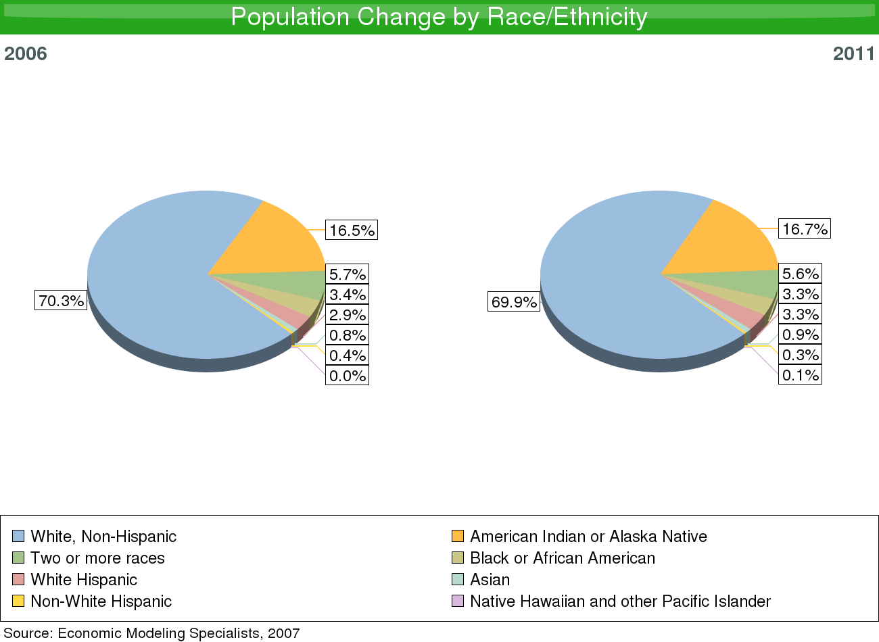

Race/Ethnicity | 2006 Population | 2011 Population | Change | % Change
White, Non-Hispanic | 368,204 | 376,103 | 7,899 | 2%
American Indian or Alaska Native | 86,341 | 90,122 | 3,781 | 4%
Two or more races | 29,785 | 30,002 | 217 | 1%
Black or African American | 17,801 | 17,615 | -185 | -1%
White Hispanic | 15,053 | 17,556 | 2,503 | 17%
Asian | 4,220 | 4,676 | 456 | 11%
Non-White Hispanic | 1,932 | 1,797 | -135 | -7%
Native Hawaiian and other Pacific Islander | 208 | 272 | 64 | 31%
Source: Economic Modeling Specialists, Inc. - 5/07

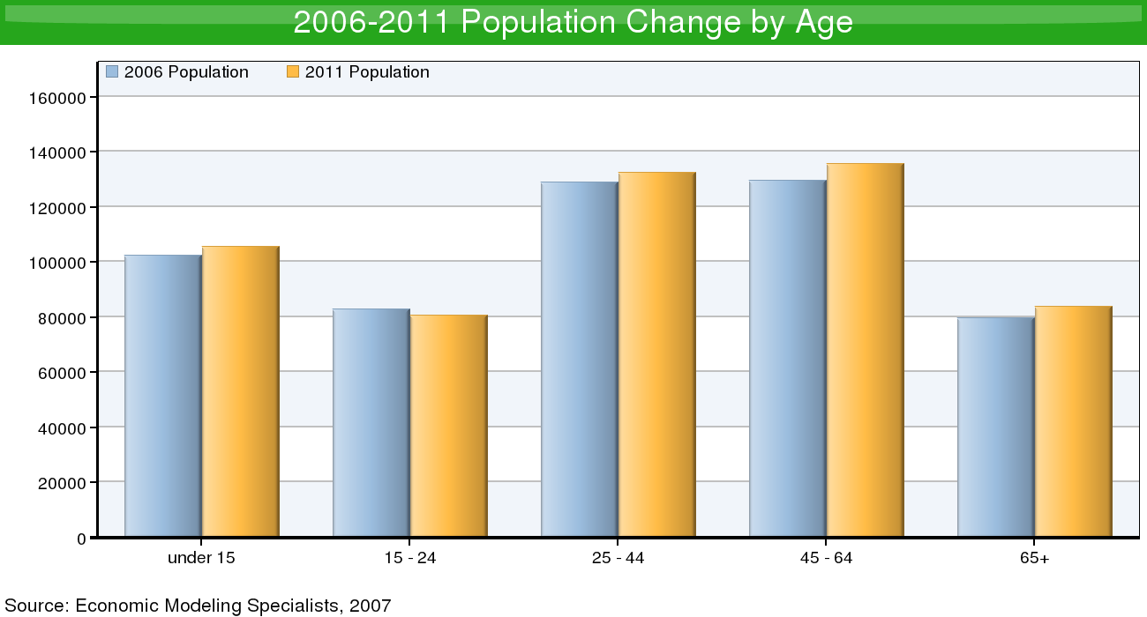

Age | 2006 Population | 2011 Population | Change | % Change
under 15 | 102,491 | 105,446 | 2,955 | 3%
15 - 24 | 82,831 | 80,488 | -2,343 | -3%
25 - 44 | 128,996 | 132,546 | 3,549 | 3%
45 - 64 | 129,572 | 135,735 | 6,163 | 5%
65+ | 79,653 | 83,929 | 4,276 | 5%
Source: Economic Modeling Specialists, Inc. - 5/07

